CS5590 APS

Programming for Web/Cloud based Application

ASSIGNMENT 1

**STEP1:**

**PAGE 1:**

In this assignment I started with the fill_details.html where the details of the student will be taken.

I used form elements and well elements to create a box and take input values. When the student hits submit button, the page will be redirected to the next page where the courses will be displayed.

**CODE SNIPPETS 1:**

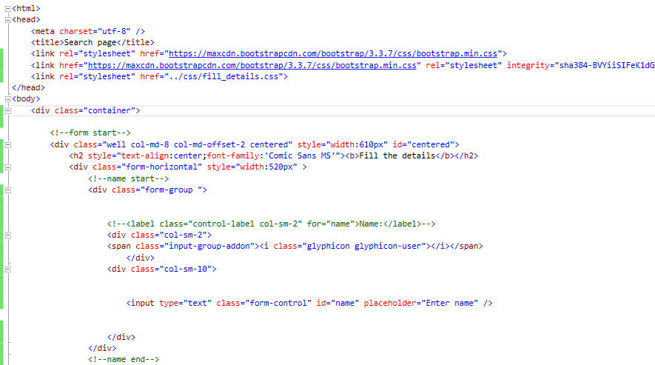

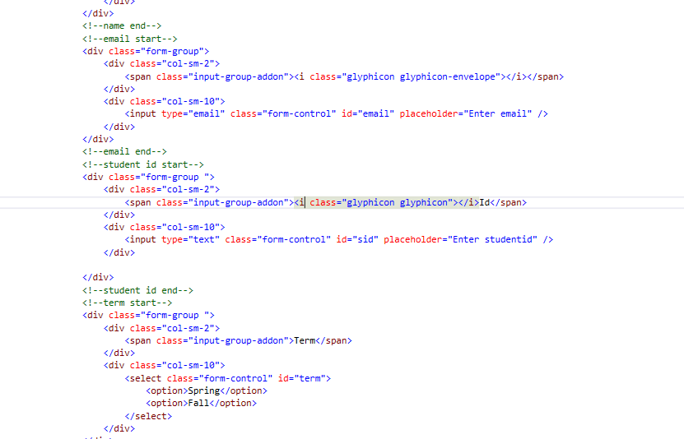

**OUTPUT 1:**

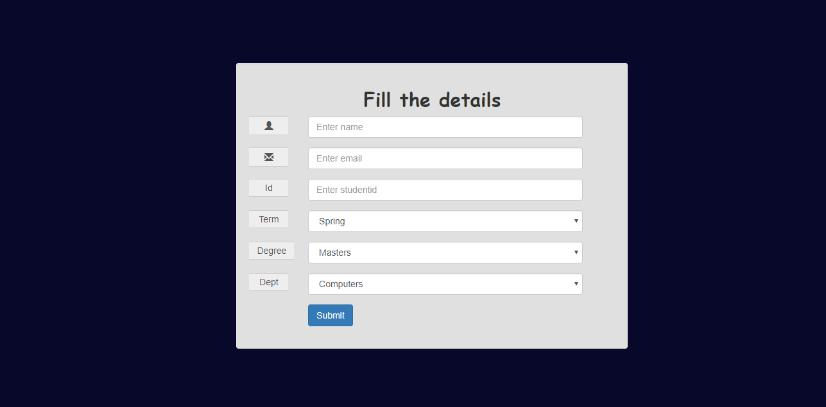

**STEP 2:**

**PAGE 2:**

On the second page which is courses.html I used panels which are foldable to represent the subjects. In this page the subjects are shown as per the options selected by the student in the first page.

All the details of the subjects will be shown like Instructor, Course id, Subject name, No.of credits, Course location, description, prerequisites etc..

Each subject has an image in appropriate to the course.

When the student selects the desired course the page will be redirected to the next page where the total seats and remaining seats will be displayed.

For example if a student selects Courses for fall semester, and masters in computers then the following courses will be displayed.

**OUTPUT 2:**





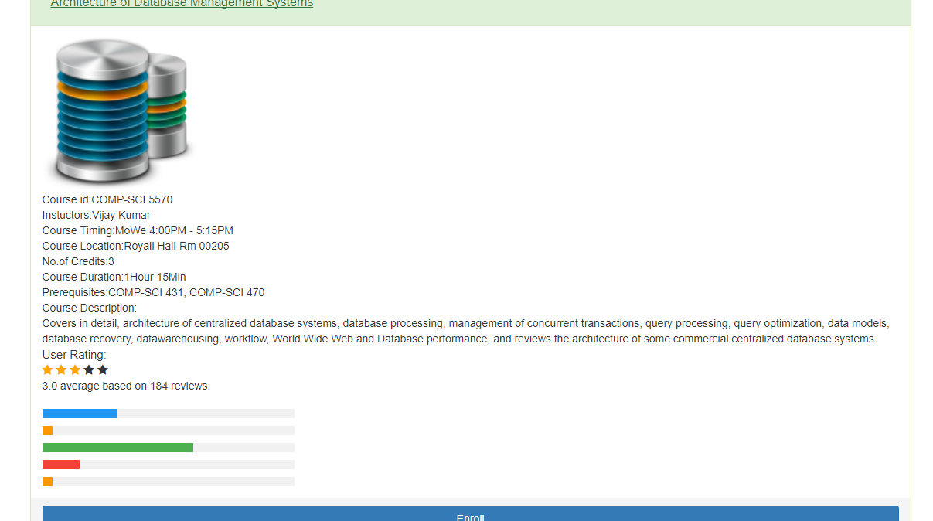

**CODE SNIPPETS 2:**

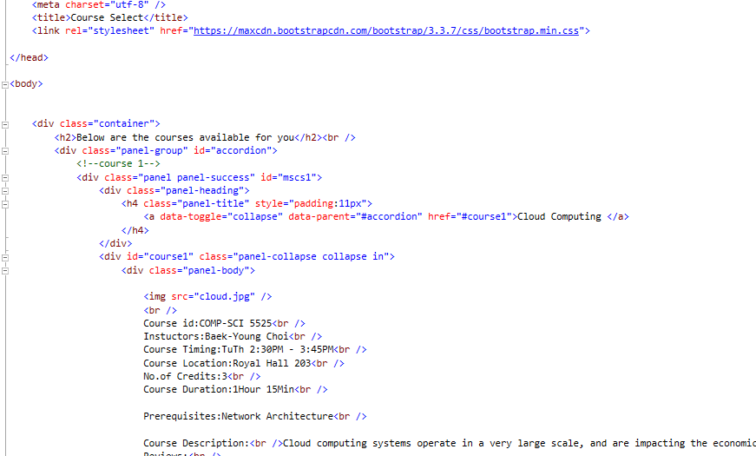

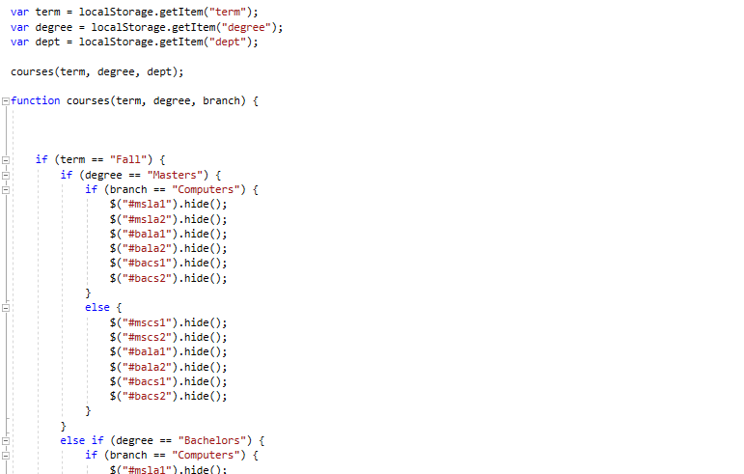

**STEP 3:**

**PAGE 3:**

Now on the third page the course which was opted by the student will be shown along with the seats available and total seats. If the student wishes to continue he can confirm his enrollment by clicking the confirm enrollment button which then redirects him/her to the final page to show that the registration was successful.

The same elements which were used in the second page were used here(panels).

Here I inserted a counter and as the students press the enroll button the no.of seats decrease.

**OUTPUT 3:**

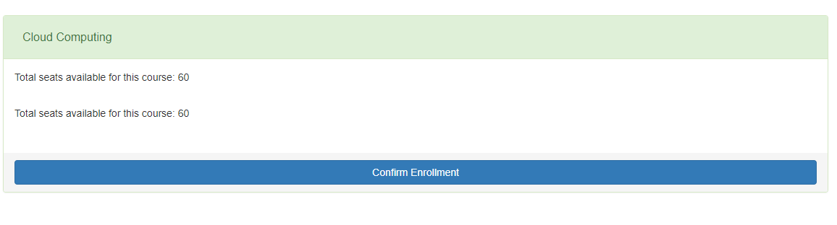

**CODE SNIPPETS 3:**

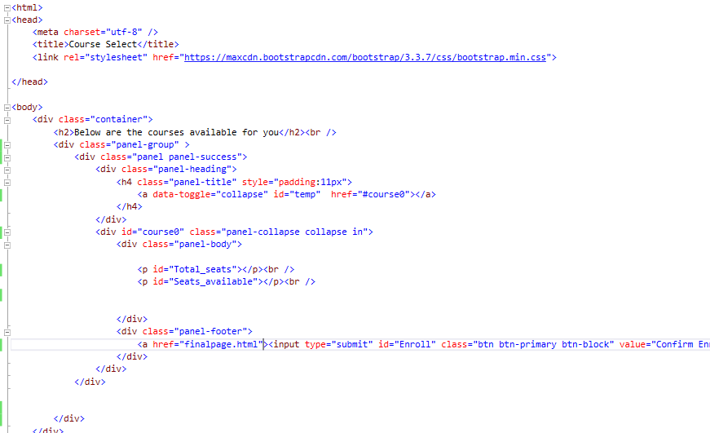

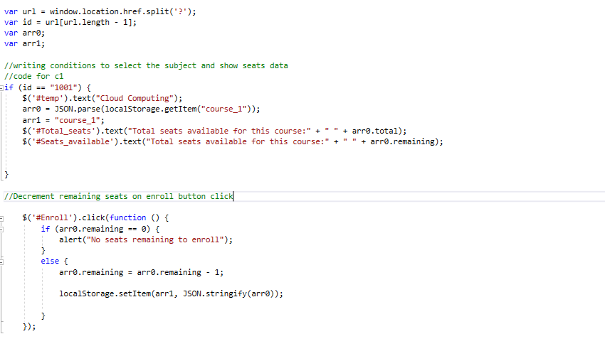

**Final page:**

In the final page Successfully registered dialogue box is shown and if the student wishes to go back to the home page he/she can click the home page button.

**Output Final:**



The Webpages are responsive it means the elements resize automatically as we increase and decrease the window size.

**Responsiveness screenshots:**



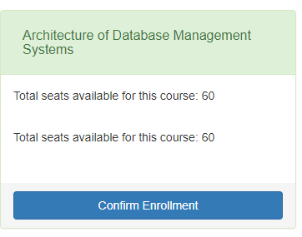

**Problem faced:**

The major problem I faced is to store the values that students give and pass them to the next page. I used local storage as a solution for this. I stored the given values in the local storage and then retrieved the values from the local storage whenever required. It worked perfectly.